Detecting Suspicious Process using Sysmon and Powershell

Introduction
In this particular document, we provide steps to identify different system events information about the processes mentioned in the captured screenshot while using Sysmon on a window system. The idea is to monitor these process for various indecencies like the connections to other networks, change in files, registry, and termination of the process. Sysmon logs are parsed with PowerShell scripts to extract particular events for refinement.

Sysmon Event Detection
Some of the recognized processes are svchost.exe, MsVPNClientSvc.exe, MpWBFPolicyService.exe, mysqld.exe, MsMpEng.exe, taskhostw.exe and others.
To monitor and detect relevant activities of these processes, we leveraged the following Sysmon Event IDs:
- Process Termination (Event ID 5): Records when the listed processes end:
- Image Load (Event ID 7): Identifies the DLLs or the modules which are associated with these processes can provide view to DLL injection.
- Network Connections (Event ID 3): It tracks the outgoing network connections established by the process mentioned above.
- File Creation/Modification (Event ID 11): Ability to find out files that are created or modified by such processes necessary in detecting data modification or malware operation.
- Registry Modifications (Event ID 13): Monitors modifications to the windows registry which is favorite for persistence among most malicious programs.

PowerShell Implementation
For each event type, tailored PowerShell scripts were written to:
- Search on Sysmon logs in Microsoft-Windows-Sysmon/Operational.

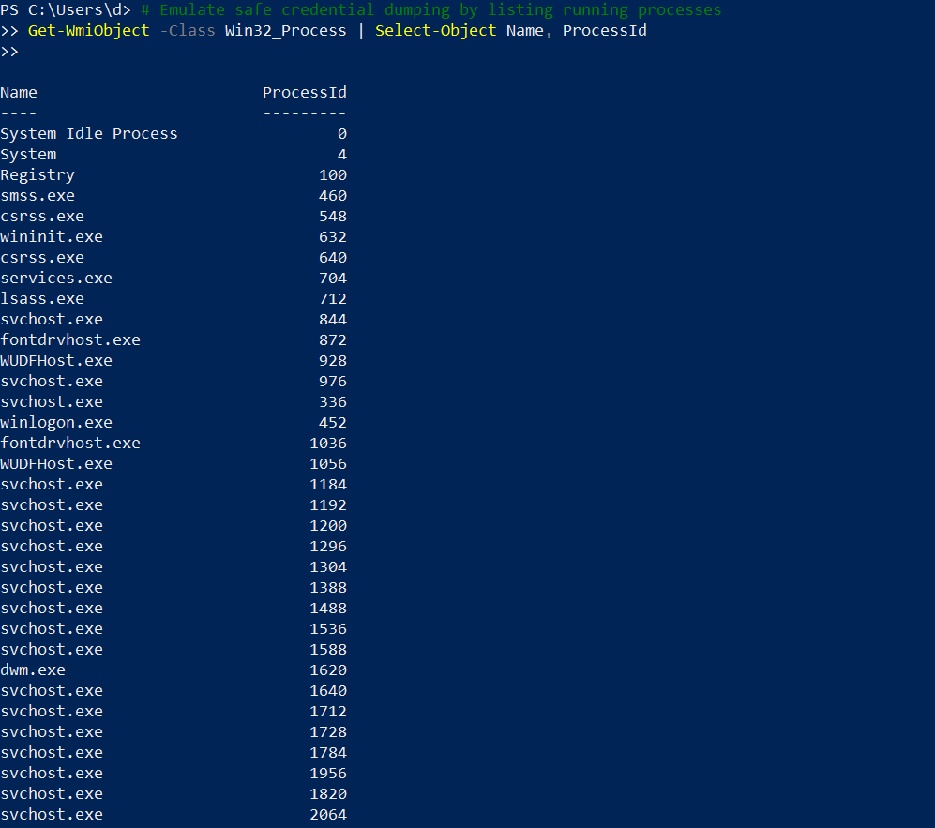

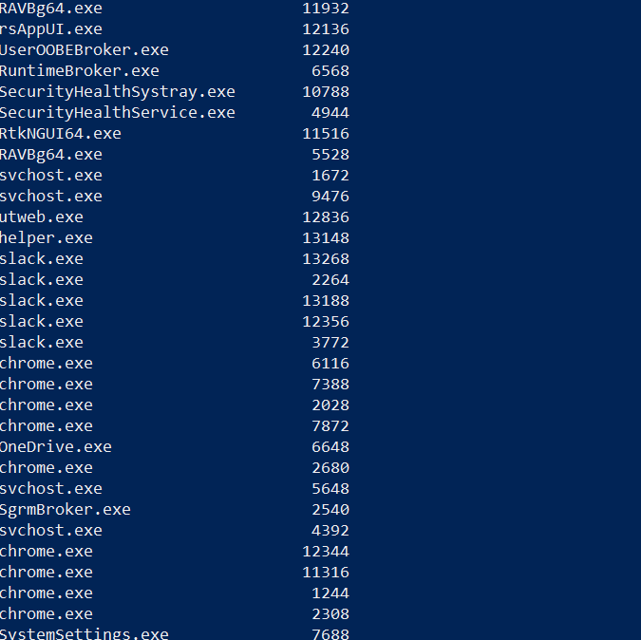

- Per-type filter concerning process names like svchost.exe, MsVPNClientSvc.exe, and others.

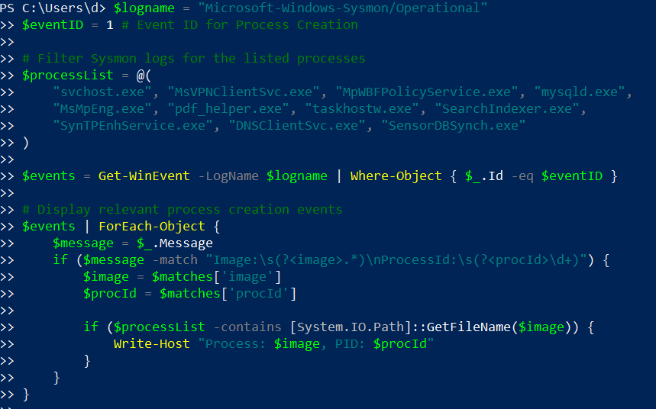

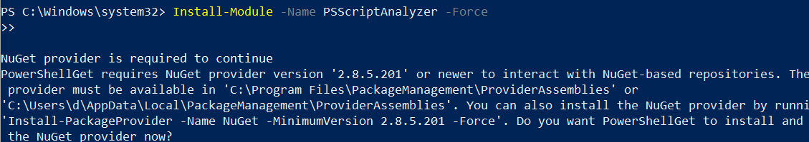

- Identify and list processes and their attributes like process name, process ID, path of the image, network connection and many others.

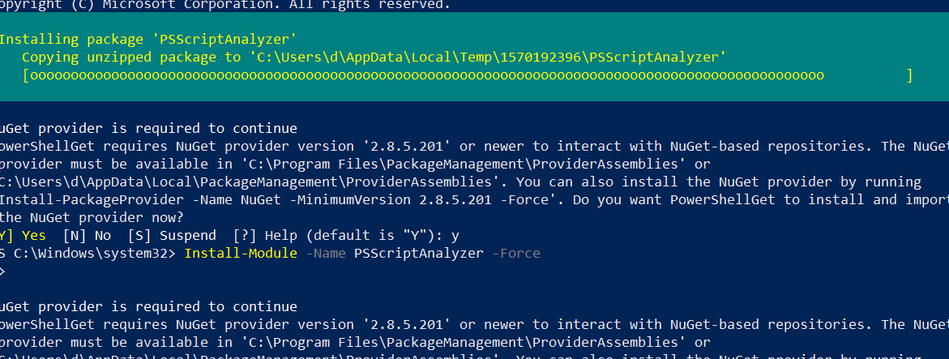

Conclusion

Such events help system administrators observe events that are related to crucial procedures and other suspicious activities. Event log generated by Sysmon with help of PowerShell allows real-time process analysis from process activity, image and process loading connectivity, network connections, file operations, and registry activity. These insights provide additional support to system defenses against threats like malware, the movement through systems, and any change not approved by the security team. Periodical security check and Log analysis are essential for security.

